**Introduction:**

In this tableau analysis, we delve into the profound impacts of the COVID-19 pandemic, the global recession, and the Russia-Ukraine war on the intricate tapestry of global economic growth.

Unraveling the intricate threads of economic dynamics, this tableau presentation illuminates the interconnected repercussions stemming from the trifecta of the COVID-19 crisis, the global recession, and the ongoing Russia-Ukraine conflict.

Through the lens of Tableau, we navigate the intricate landscape of global economic growth, dissecting the multifaceted influences exerted by the COVID-19 pandemic, the reverberations of a global recession, and the geopolitical ramifications of the Russia-Ukraine war.

**Target Audience:**

Tailored for economists, policymakers, and financial analysts, this presentation provides a comprehensive tableau analysis to aid in understanding the nuanced effects of the COVID-19 pandemic, global recession, and Russia-Ukraine conflict on economic landscapes.

Ideal for business leaders, investors, and decision-makers, this tableau exploration serves as a strategic guide, offering insights into navigating the intricate challenges posed by the interwoven forces of the COVID-19 impact, global recession, and geopolitical tensions.

Geared towards academics, researchers, and students in the fields of economics and international relations, this tableau-based study presents an in-depth examination of the symbiotic relationship between the COVID-19 crisis, global recession, and the Russia-Ukraine war, fostering a deeper comprehension of their collective impact on global economic growth.

**Data Cleaning & Processing:**

Rigorous data cleaning and processing formed the foundation of our project, ensuring the integrity and reliability of our analysis by addressing inconsistencies, outliers, and missing values in the dataset.

A meticulous data cleaning and processing phase was undertaken to refine our dataset, involving the identification and rectification of anomalies, normalization of variables, and strategic handling of outliers to enhance the accuracy of our findings.

Leveraging advanced data cleaning techniques, we meticulously curated and processed our dataset, implementing thorough validation protocols to enhance the precision and credibility of our analytical insights.

**Dashboard 1:**

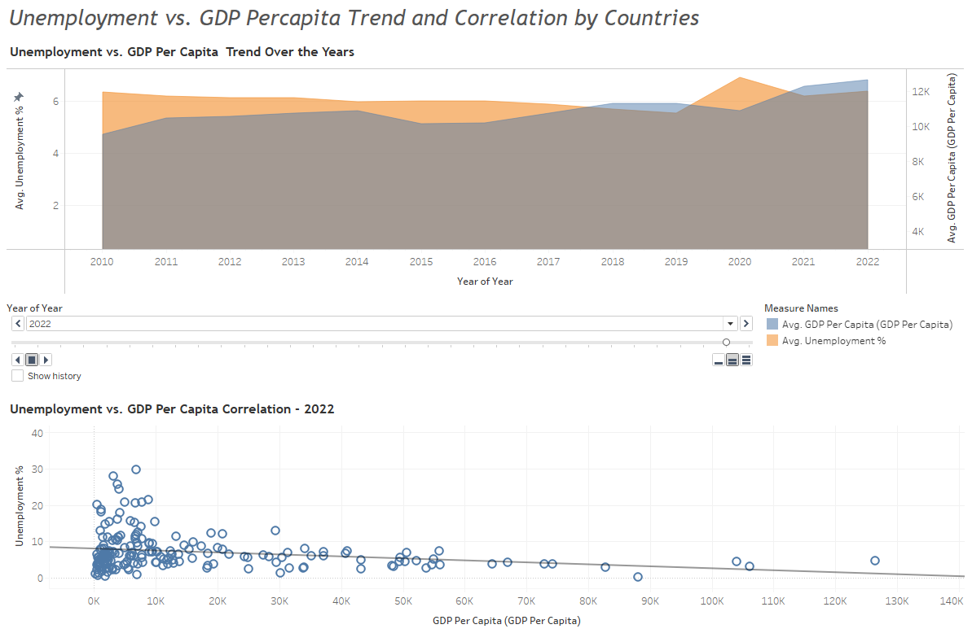

The statistical techniques employed in the analysis involve time-series analysis and correlation analysis.

**1. Time-series analysis:** This technique is used to examine patterns and trends in data over a period of time. In the given insights, it's applied to study the changing trends in average GDP per capita and unemployment rates from 2010 to 2022. Time-series analysis helps identify long-term patterns, seasonal variations, and overall trends in the economic indicators, providing a comprehensive view of how these variables evolve over time.

**2. Correlation analysis:** This statistical method assesses the strength and direction of the linear relationship between two variables. In this context, it's used to understand the correlation between average GDP per capita and average unemployment rates. A positive correlation suggests that as GDP per capita increases, unemployment rates tend to decrease, and vice versa. Conversely, a negative correlation implies an inverse relationship. The correlation coefficient, a key output of this analysis, quantifies the degree to which these variables are related.

These statistical techniques provide valuable insights into the dynamics of the global economy, allowing analysts to discern patterns, make predictions, and understand the interplay between key economic indicators.

**Dashboard 2:**

The insights highlight a correlation between new COVID-19 cases and unemployment rates globally. In 2019, there were no recorded new cases, but by 2023, there was a significant spike to 42,642,697 cases. Concurrently, global unemployment rates experienced fluctuations from 5.54% in 2019 to 6.37% in 2022, followed by a slight decrease to 5.77% in 2023. The second set of data for 2022 compares average new cases and unemployment rates by country, revealing diverse trends. Qatar, with minimal new cases, exhibited the lowest unemployment rate (0.095%), while South Africa faced both high new cases (11,754) and a staggering 29.81% unemployment rate. Statistical techniques such as averages were likely employed to derive insights, emphasizing the complex interplay between health crises and economic indicators.

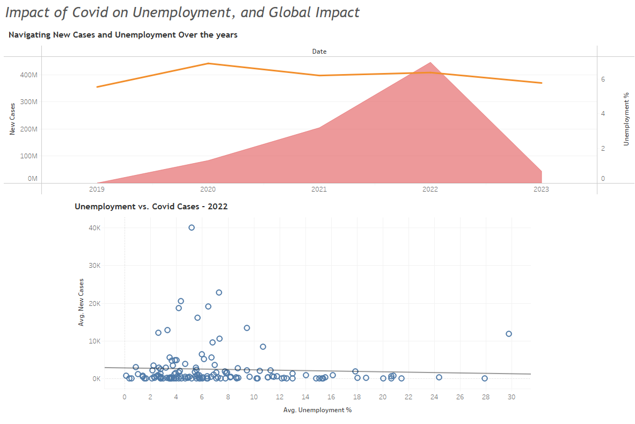

The statistical technique employed in the analysis involves calculating averages to summarize and compare the data. For the first set of insights, the unemployment rates for the years 2019 to 2023 were presented, and the statistical technique involved analyzing the average unemployment rate over this period. This provides a consolidated measure that captures the overall trend in unemployment.

In the second set of insights for 2022, the average new cases and average unemployment rates for various countries were computed. Averages allow for a simplified representation of the central tendency of the data, offering a snapshot of the typical values within the given context. This statistical technique helps identify general patterns and variations in the relationship between COVID-19 cases and unemployment across different countries.

**Dashboard 3:**

The statistical technique used in the first set of insights, related to GDP per capita forecasting, is time series forecasting. Time series forecasting involves predicting future values of a variable based on its past values. In this case, the variable of interest is GDP per capita, and the forecasting is done year by year. The lower and upper prediction intervals provide a range of possible values for GDP per capita in the future, reflecting the uncertainty associated with the forecasts. This technique typically involves using historical data to identify patterns and trends, which are then used to make predictions about future values.

In the second set of insights, the statistical technique used is correlation analysis. Correlation measures the strength and direction of a linear relationship between two variables. In this context, the variables are average inflation rate and GDP growth for various countries. A positive correlation indicates that higher inflation is associated with higher GDP growth, while a negative correlation suggests the opposite. The correlation coefficient quantifies the degree of association, ranging from -1 to 1. A coefficient close to 1 or -1 implies a strong correlation, while a coefficient close to 0 suggests a weak or no correlation. Correlation analysis helps understand the interdependence between economic indicators.

**Dashboard 4:**

The first set of insights provides a forecast of the Inflation Rate Trend, incorporating Year-on-Year GDP Growth, Lower and Upper Prediction Intervals, and the Inflation Rate. Notably, the data indicates an increasing trend in inflation rates from 2017 to the estimated values for 2023 to 2026. The statistical technique employed here likely involves time series analysis and regression modeling to predict future inflation rates based on historical GDP growth patterns.

The second set explores the relationship between Unemployment and Inflation in various countries. It reveals diverse average inflation rates and unemployment percentages, suggesting a complex interplay between these economic indicators. A correlation analysis might have been employed to examine the strength and direction of the relationship between unemployment and inflation. Countries such as Zimbabwe and Sudan exhibit extreme values, emphasizing the significance of analyzing these economic factors on a global scale.

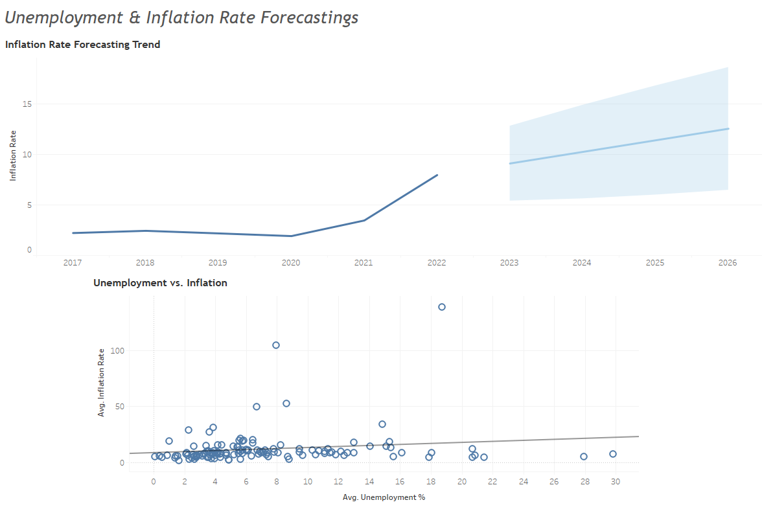

The statistical techniques used in the analysis of the Inflation Rate Forecasting Trend likely involve time series analysis and regression modeling. Time series analysis is employed to examine trends and patterns in economic data over time, capturing the sequential nature of observations. Regression modeling, on the other hand, enables the identification of relationships between variables. In this context, the Year-on-Year GDP Growth serves as an independent variable, and the Inflation Rate is the dependent variable. The Lower and Upper Prediction Intervals provide a range of uncertainty around the predicted values, indicating the level of confidence in the forecasts. These techniques collectively help in understanding and predicting the dynamics of inflation rates based on historical economic data.

**References:**

<https://data.worldbank.org/indicator/NY.GDP.PCAP.CD>

<https://www.kaggle.com/datasets/debashish311601/commodity-prices/discussion>

<https://data.worldbank.org/indicator/FP.CPI.TOTL.ZG>